Bootstrap is a free front-end framework for faster and easier web development

Why Bootstrap

* **Easy to use:** Anybody with just basic knowledge of HTML and CSS can start using Bootstrap
* **Responsive features:** Bootstrap's responsive CSS adjusts to phones, tablets, and desktops
* **Mobile-first approach:** In Bootstrap 3, mobile-first styles are part of the core framework
* **Browser compatibility:** Bootstrap is compatible with all modern browsers (Chrome, Firefox, Internet Explorer, Edge, Safari, and Opera)

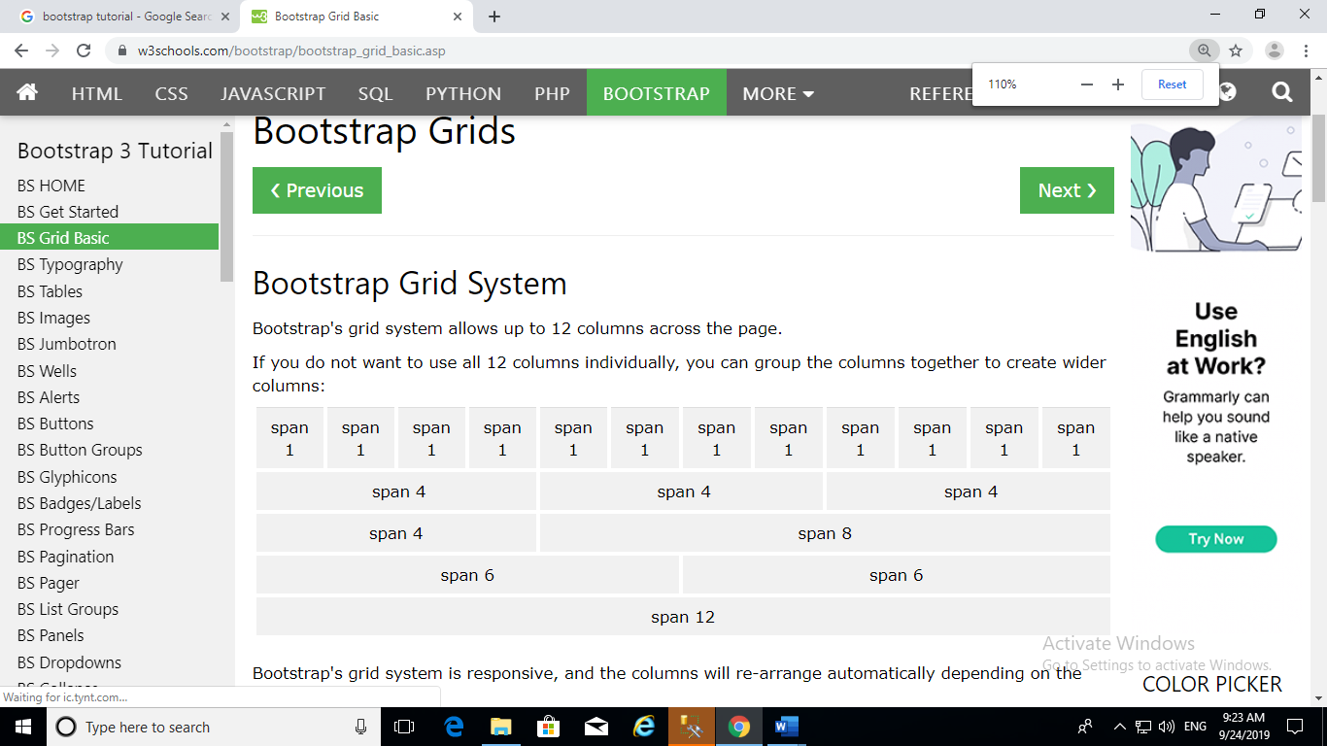

Grid Classes

The Bootstrap grid system has four classes:

* xs (for phones - screens less than 768px wide)
* sm (for tablets - screens equal to or greater than 768px wide)
* md (for small laptops - screens equal to or greater than 992px wide)
* lg (for laptops and desktops - screens equal to or greater than 1200px wide)

Basic Grid Structure

<div class="row">  
  <div class="col-*-*"></div>  
  <div class="col-*-*"></div>  
</div>  
<div class="row">  
  <div class="col-*-*"></div>  
  <div class="col-*-*"></div>  
  <div class="col-*-*"></div>  
</div>  
<div class="row">  
  ...  
</div>

Ex1:

<!DOCTYPE html>

<html>

<head>

<meta charset="utf-8" />

<!--responsive page-->

<meta name="viewport" content="width=device-width, initial-scale=1, shrink-to-fit=no">

<link href="bootstrap/css/bootstrap.min.css" rel="stylesheet" />

<script src="bootstrap/js/bootstrap.min.js"></script>

<title>Grid structure</title>

<style>

.GridStyle{

margin:10px;

min-height:200px;

background-color:coral;

text-align:justify;

font-size:medium

}

</style>

</head>

<body>

<div class="container-fluid">

<!--<div class="row">

<div class="col-md-2">

<div class="GridStyle">

Bootstrap is

developed mobile first, a strategy in

</div>

</div>

<div class="col-md-8">

<div class="GridStyle">

Bootstrap is

developed mobile first, a strategy in

</div>

</div>

<div class="col-md-2">

<div class="GridStyle">

Bootstrap is

developed mobile first, a strategy in

</div>

</div>

</div>-->

<div class="row">

<div class="col-md-3 col-lg-9 col-sm-6">

<div class="GridStyle">

Bootstrap is

developed mobile first, a strategy in

</div>

</div>

<div class="col-md-3 col-lg-3 col-sm-6">

<div class="GridStyle">

Bootstrap is

developed mobile first, a strategy in

</div>

</div>

<div class="col-md-3 col-lg-9 col-sm-6">

<div class="GridStyle">

Bootstrap is

developed mobile first, a strategy in

</div>

</div>

<div class="col-md-3 col-lg-3 col-sm-6">

<div class="GridStyle">

Bootstrap is

developed mobile first, a strategy in

</div>

</div>

</div>

</div>

</body>

</html>

Ex2:

<!DOCTYPE html>

<html>

<head>

<meta charset="utf-8" />

<meta name="viewport" content="width=device-width, initial-scale=1, shrink-to-fit=no">

<link href="bootstrap/css/bootstrap.min.css" rel="stylesheet" />

<script src="bootstrap/js/bootstrap.min.js"></script>

<title></title>

<style>

.GridStyle {

margin: 5px;

text-align: justify;

text-decoration-color: crimson;

}

</style>

</head>

<body>

<div class="container-fluid">

<div class="jumbotron">

<h1>Hotel Booking</h1>

<p>Short desc!!!!!!!!!!!</p>

</div>

<div class="row">

<div class="col-md-3 col-lg-9 col-sm-6">

<div class="GridStyle">

Bootstrap is developed mobile first, a strategy in which we optimize code for mobile devices first and then scale up components as necessary using CSS media queries. To ensure proper rendering and touch zooming for all devices,

add the responsive viewport meta tag to your

</div>

</div>

<div class="col-md-3 col-lg-3 col-sm-6">

<div class="GridStyle">

Bootstrap is developed mobile first, a strategy in which we optimize code for mobile devices first and then scale up components as necessary using CSS media queries. To ensure proper rendering and touch zooming for all devices,

add the responsive viewport meta tag to your

</div>

</div>

<div class="col-md-3 col-lg-9 col-sm-6">

<div class="GridStyle">

Bootstrap is developed mobile first, a strategy in which we optimize code for mobile devices first and then scale up components as necessary using CSS media queries. To ensure proper rendering and touch zooming for all devices,

add the responsive viewport meta tag to your

</div>

</div>

<div class="col-md-3 col-lg-3 col-sm-6">

<div class="GridStyle">

Bootstrap is developed mobile first, a strategy in which we optimize code for mobile devices first and then scale up components as necessary using CSS media queries. To ensure proper rendering and touch zooming for all devices,

add the responsive viewport meta tag to your

</div>

</div>

</div>

<br/>

<h2>TABLE</h2>

</div>

</body>

</html>

Ex3

<!DOCTYPE html>

<html>

<head>

<meta charset="utf-8" />

<meta name="viewport" content="width=device-width, initial-scale=1, shrink-to-fit=no">

<link href="bootstrap/css/bootstrap.min.css" rel="stylesheet" />

<script src="bootstrap/js/bootstrap.min.js"></script>

<title></title>

</head>

<body>

<div class="container">

<h2>TABLE</h2>

<table class=" table table-dark table-responsive-md">

<thead>

<tr>

<th>Name</th>

<th>City</th>

<th>Score</th>

</tr>

</thead>

<tbody>

<tr>

<td>SAI</td>

<td>PUNE</td>

<td>90</td>

</tr>

<tr>

<td>GEETHA</td>

<td>PUNE</td>

<td>80</td>

</tr>

<tr>

<td>ABI</td>

<td>PUNE</td>

<td>90</td>

</tr>

</tbody>

</table>

</div>

</body>

</html>

EX4:

<!DOCTYPE html>

<html>

<head>

<meta charset="utf-8" />

<meta name="viewport" content="width=device-width, initial-scale=1, shrink-to-fit=no">

<link href="bootstrap/css/bootstrap.min.css" rel="stylesheet" />

<script src="bootstrap/js/bootstrap.min.js"></script>

<title>ImageGallery</title>

<style>

.myimg:hover{

transform:scale(0.9);

}

</style>

</head>

<body>

<div class="container-fluid">

<h1>ImageGallery</h1>

<div class="row">

<div class="col-md-4 col-lg-3 col-sm-6">

<a href="Images/Dora.jpg " >

<p>Dora</p>

<div class="myimg"> <img src="Images/Dora.jpg" alt="Dora" class="img-thumbnail" style=" height: 250px;

width: 100%;"/></div>

</a>

</div>

<div class="col-md-4 col-lg-3 col-sm-6">

<a href="Images/Micky.jpg" >

<p>Micky</p>

<div class="myimg"> <img src="Images/Micky.jpg" alt="Micky" class="img-thumbnail" style=" height: 250px;

width: 100%;" /></div>

</a>

</div>

<div class="col-md-4 col-lg-3 col-sm-6">

<a href="Images/Nala.jpg" >

<p>Nala</p>

<div class="myimg"> <img src="Images/Nala.jpg" alt="Nala" class="img-thumbnail" style=" height: 250px;

width: 100%;"/></div>

</a>

</div>

<div class="col-md-4 col-lg-3 col-sm-6">

<a href="Images/Ponda.jpg" >

<p>Ponda</p>

<div class="myimg"> <img src="Images/Ponda.jpg" alt="Ponda" class="img-thumbnail" style=" height: 250px;

width: 100%;"/></div>

</a>

</div>

<div class="col-md-4 col-lg-3 col-sm-6">

<a href="Images/Pumba.jpg" >

<p>Pumba</p>

<div class="myimg"> <img src="Images/Pumba.jpg" alt="Pumba" class="img-thumbnail"style=" height: 250px;

width: 100%;"/></div>

</a>

</div>

</div>

</div>

</body>

</html>

Ex5:

<!DOCTYPE html>

<html>

<head>

<meta charset="utf-8" />

<meta name="viewport" content="width=device-width, initial-scale=1, shrink-to-fit=no">

<link href="bootstrap/css/bootstrap.min.css" rel="stylesheet" />

<script src="bootstrap/js/bootstrap.min.js"></script>

<title></title>

</head>

<body>

<div class="container">

<h2>Alerts</h2>

<div class="alert alert-success"> I am here to explain Success!!!!</div>

<br />

<div class="alert alert-danger ">

I am here to explain Danger!

</div>

<br />

<div class="alert alert-primary ">

I am here to explain Primary!

</div>

<hr />

<h2>Button</h2>

<button type="button" class="btn-primary">Primary</button>

<button type="button" class="btn-dark">dark</button>

<button type="button" class="btn-outline-warning">danger</button>

<h2>Vertical button group</h2>

<div class="btn-group-vertical ">

<button type="button" class="btn-dark">Home</button>

<button type="button" class="btn-dark">AboutUs</button>

<button type="button" class="btn-dark">Contact</button>

</div>

<h2>Horizontal button group</h2>

<div class="btn-group ">

<button type="button" class="btn-dark">Home</button>

<button type="button" class="btn-dark">AboutUs</button>

<button type="button" class="btn-dark">Contact</button>

</div>

<h2>Pagination</h2>

<ul class="pagination">

<li class="page-item"><a class="page-link" href="#">Previous</a></li>

<li class="page-item active"><a class="page-link" href="#">1</a></li>

<li class="page-item"><a class="page-link" href="#">2</a></li>

<li class="page-item"><a class="page-link" href="#">3</a></li>

<li class="page-item disabled"><a class="page-link" href="#">Next</a></li>

</ul>

<h2>breadcrumb</h2>

<ul class="breadcrumb">

<li class="breadcrumb-item"><a href="#">1</a></li>

<li class="breadcrumb-item"><a href="#">2</a></li>

<li class="breadcrumb-item"><a href="#">3</a></li>

<li class="breadcrumb-item active">4</li>

</ul>

</div>

</body>

</html>

Ex6:

<!DOCTYPE html>

<html>

<head>

<meta charset="utf-8" />

<meta name="viewport" content="width=device-width, initial-scale=1, shrink-to-fit=no">

<link href="bootstrap/css/bootstrap.min.css" rel="stylesheet" />

<script src="bootstrap/js/bootstrap.min.js"></script>

<link rel="stylesheet" href="https://maxcdn.bootstrapcdn.com/bootstrap/3.4.0/css/bootstrap.min.css">

<script src="https://ajax.googleapis.com/ajax/libs/jquery/3.4.1/jquery.min.js"></script>

<script src="https://maxcdn.bootstrapcdn.com/bootstrap/3.4.0/js/bootstrap.min.js"></script>

<title></title>

</head>

<body>

<div class="container">

<h2>Pager</h2>

<p>The .pager class provides previous and next buttons (links):</p>

<ul class="pager">

<li><a href="#">Previous</a></li>

<li><a href="#">Next</a></li>

</ul>

<hr/>

<div class="card">

<div class="card-header">Header</div>

<div class="card-body">Content</div>

<div class="card-footer">Footer</div>

</div>

<br /><br />

<div class="card">

<div class="card-header">Phone</div>

<div class="card-body">

<h4 class="card-title">Iphone</h4>

<p class="card-text">Some example text. Some example text.</p>

<a href="#" class="card-link">Card link</a>

<a href="#" class="card-link">Another link</a>

</div>

</div>

<br /><br />

<div class="card" style="width:300px">

<div class="card-body">

<h4 class="card-title">WallPaper</h4>

<img src="Images/Jerry.png" />

<button class="btn-primary">BUY</button>

</div>

</div>

</div>

</body>

</html>

Ex7:

<!DOCTYPE html>

<html>

<head>

<meta charset="utf-8" />

<meta http-equiv="X-UA-Compatible" content="IE=edge">

<meta name="viewport" content="width=device-width, initial-scale=1">

<!-- The above 3 meta tags *must* come first in the head; any other head content must come *after* these tags -->

<title>Carousel Example</title>

<link href="bootstrap/css/bootstrap.min.css" rel="stylesheet" />

<!-- Bootstrap -->

<style>

.carousel-inner .item img {

width: 100%;

height: 360px;

}

</style>

</head>

<body>

<div class="container-fluid">

<div class="row">

<div class="col-md-12">

<div id="imageCarousel" class="carousel slide" data-interval="2000"

data-ride="carousel" data-pause="hover" data-wrap="true">

<ol class="carousel-indicators">

<li data-target="#imageCarousel" data-slide-to="0" class="active"></li>

<li data-target="#imageCarousel" data-slide-to="1"></li>

<li data-target="#imageCarousel" data-slide-to="2"></li>

<li data-target="#imageCarousel" data-slide-to="3"></li>

</ol>

<div class="carousel-inner">

<div class="item active">

<img src="Images/Dora.jpg" class="img-responsive" alt="...">

<div class="carousel-caption">

<h3>Image 1</h3>

<p>Image 1 Description</p>

</div>

</div>

<div class="item ">

<img src="Images/Micky.jpg" class="img-responsive" alt="...">

<div class="carousel-caption">

<h3>Image2</h3>

<p>Image 2 Description</p>

</div>

</div>

<div class="item ">

<img src="Images/Nala.jpg" class="img-responsive" alt="...">

<div class="carousel-caption">

<h3>Image3</h3>

<p>Image 3 Description</p>

</div>

</div>

<div class="item">

<img src="Images/Pumba.jpg" class="img-responsive" alt="...">

<div class="carousel-caption">

<h3>Image4</h3>

<p>Image4 Description</p>

</div>

</div>

</div>

<a href="#imageCarousel" class="carousel-control left" data-slide="prev">

<span class="glyphicon glyphicon-chevron-left"></span>

</a>

<a href="#imageCarousel" class="carousel-control right" data-slide="next">

<span class="glyphicon glyphicon-chevron-right"></span>

</a>

</div>

</div>

</div>

</div>

<script src="https://ajax.googleapis.com/ajax/libs/jquery/1.11.3/jquery.min.js">

</script>

<script src="bootstrap/js/bootstrap.min.js"></script>

</body>

</html>